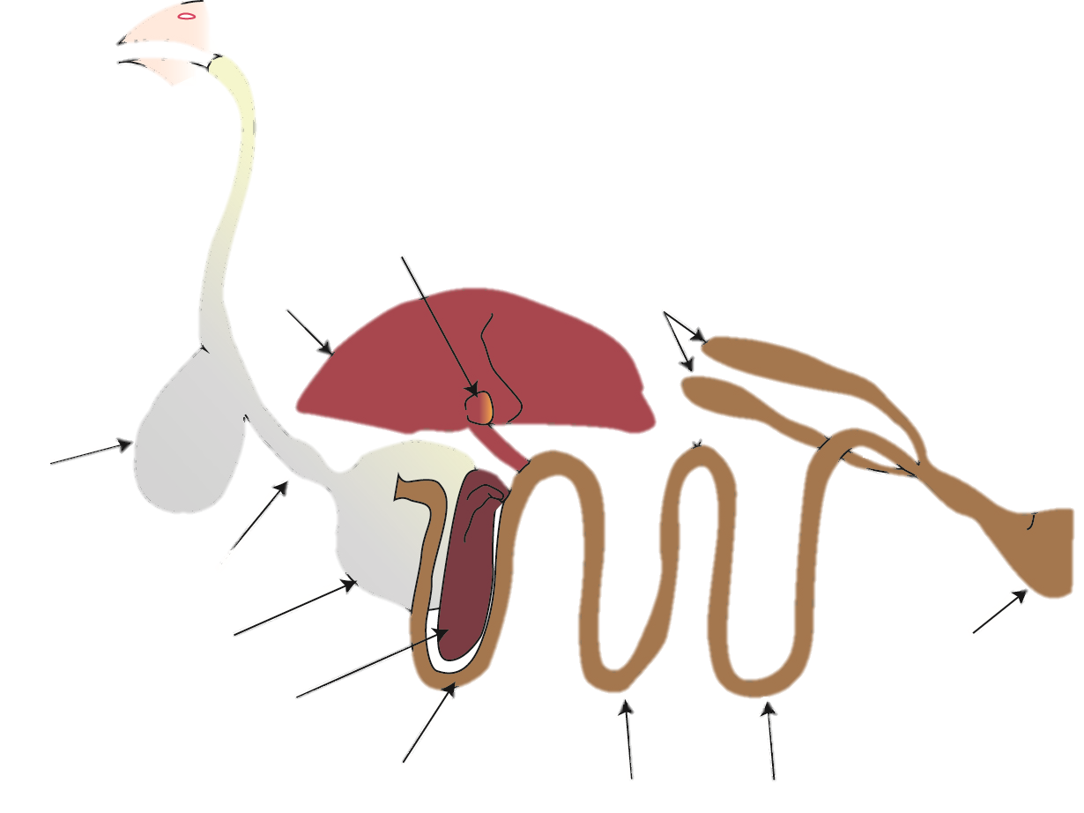
2.___________
Digestive System Labeling Quiz
9. ____________
7. _________
8. __________
11.__________
10._______
1. ___________
3.__________
4._____________
5. _____________
6. ______________
13._________
14._________
12.___________

